Stereo Power Amplifier

AP-701
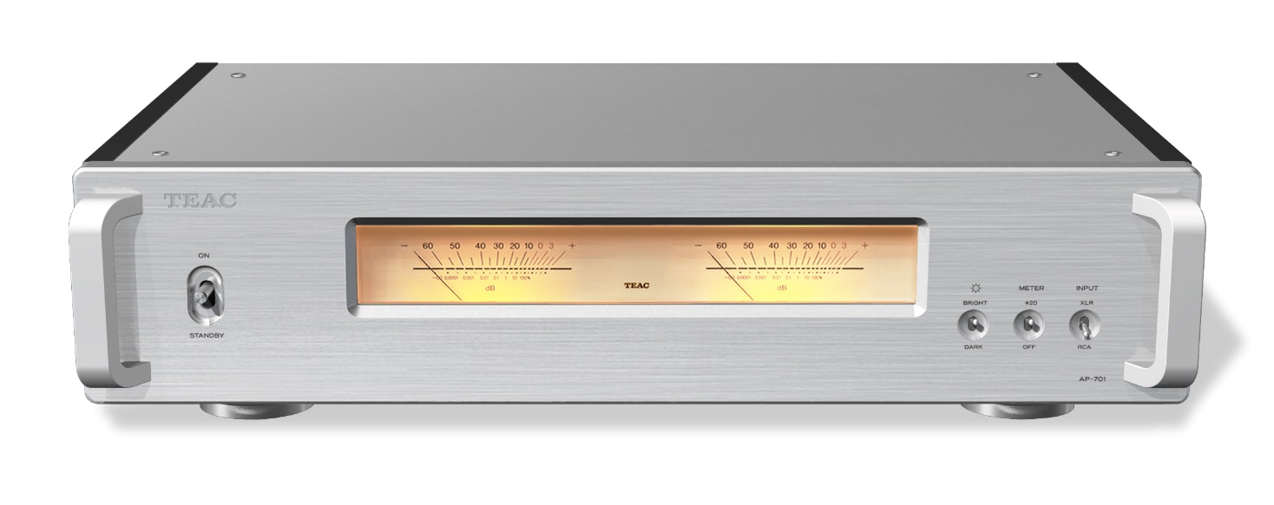

Dual mono power amplifier with fully balanced structure and two ustom made Hypex Electronics Ncore power amplifier modules

Main features
- Two Ncore power modules made by Hypex Electronics B.V. And tuned especially for this model
- High output with a practical maximum of 260 W + 260 W (4 Ω)/170 W + 170 W (8 Ω)
- Dual mono design throughout entire system
- Clean signal amplification realized with a fully balanced design at the input stage
- Two independent left/right high-capacity toroidal core power supply transformers
- Discrete buffer amplifiers used in the input stage
- Three supporting pinpoint feet that are easy to install (patent numbers 4075477 and 3778108)
- Two linked VU meters which show musical pulse; with four dimmer levels and two sensitivity settings
- Fan-free design to minimize noise
- 12V trigger in and through for power synchronization

Brand | TEAC | TEAC
Model | AP-701-S | AP-701-B
Color | Silver（S） | Black（B）
EAN Code | 490734223428 | 490734223398
Product Dimensions | 444 x 111 x 348 mm(W x H x D) / 9.9kg | 444 x 111 x 348 mm(W x H x D) / 9.9kg
Package Dimensions | 626ｘ266 x 477mm(W x H x D) /12.2 kg | 626ｘ266 x 477mm(W x H x D) /12.2kg

The unconstrained dynamism of sound awakens fundamental instincts.
The AP-701 merges all the elements desired in a power amplifier at a high level, creating a new standard.

Independent left/right high-capacity toroidal core power supply transformers, discrete buffer amplifiers and two Ncore modules provide a complete dual mono structure from input to output. Moreover, the input stage of each channel has a fully-balanced design, so the dynamism of input signals is amplified as is, maximizing the innate performance of the speakers.
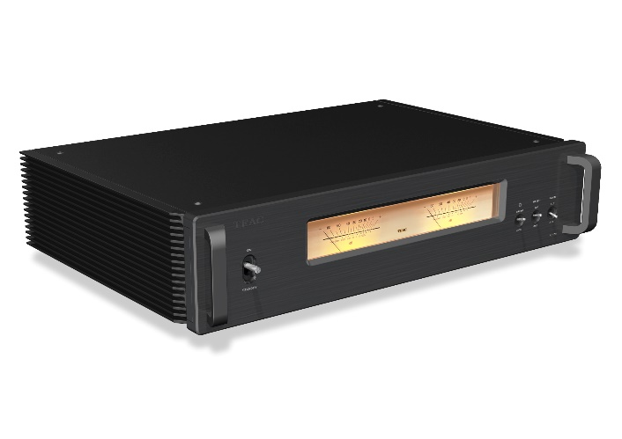
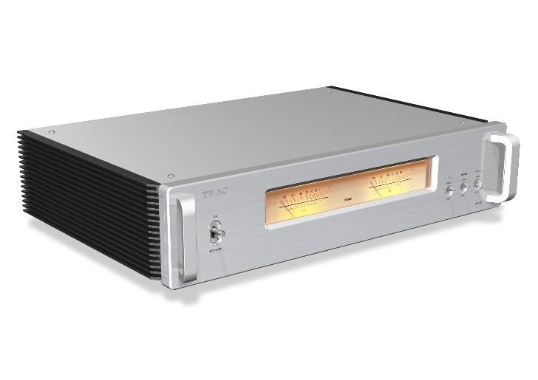
The enclosure is primarily comprised of 3mm-thick heavy sheet metal but has a flexible structure to control vibration. By incorporating joints with suspension functions, the vibration frequency of the entire device is controlled to reproduce open and vibrant sound.

AP-701-S AP-701-B

- Complete dual mono design includes power supply
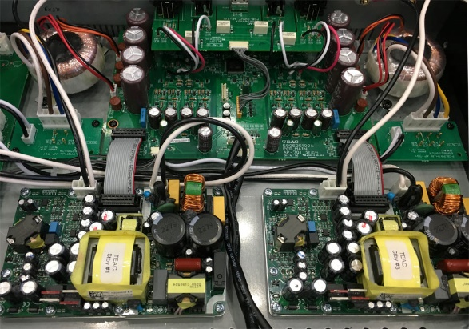
With two toroidal core power supply transformers and two Ncore modules, the extravagant circuitry has a complete dual mono structure from input to output. A dual mono structure, in which the channels are each completely mono, prevents interference between the left and right signals and achieves outstanding channel separation. This enables rich audio reproduction that provides a larger sound stage and more three dimensional sound.

(Photo of a prototype)

- High output with a practical maximum of 260 W + 260 W (4 Ω)/170 W + 170 W (8 Ω)
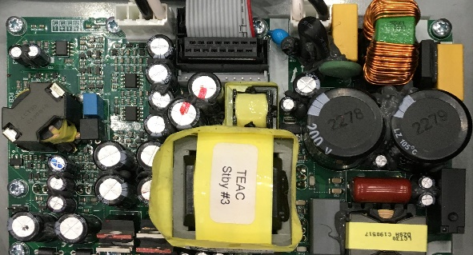
Hypex Ncore power amplifier modules realize both high efficiency and high audio quality. These two amplifier modules, which were tuned and designed specifically for TEAC, drive the speakers without losing any of the original musical expression, from delicate pianissimo to powerful fortissimo.

(Photo of a prototype)
- Vibration control from flexible structure

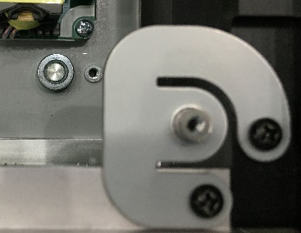
The front, side and rear panels are secured with 3mm-thick heavy sheet metal as the primary material. Then, joints that provide suspension are used at the junctures of the front, side, rear and top panels. This enclosure with a flexible structure controls the vibration of the entire device to allow open and vibrant sound reproduction.

- Fan-free design achieved with effective ventilation system

Despite the high output of this power amplifier, a fan-free design has been realized with circuit board placement calculated for airflow and precise layout of air inlets and outlets. Heat dispersion is increased by attaching the amplifier modules directly to the bottom panel. Along with the fin structure of the side panels, this reliably abates internal heat.

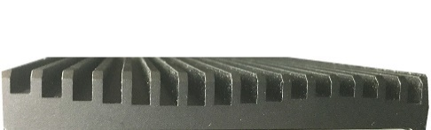
- Extensive design for vibration control
A floating structure keeps the transformers, which can easily cause vibration, detached from the bottom panel. The form of the side panel fins, which provide heat dispersion, have been adjusted to eliminate vibration.
In order to suppress vibrations that affect audio quality thoroughly, the TEAC original pin-point feet that utilize a new mechanism are attached to the bottom panel with appropriate allowance, while a number of screws that fix the circuit boards to the chassis is minimized.

- Numerous features for audio quality
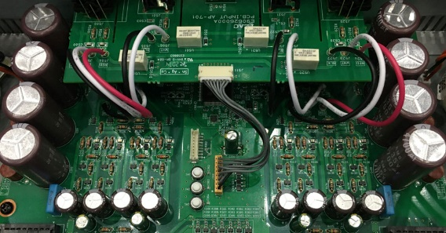
The durability of input circuits is ensured by including slits between each connector. In addition, direct wiring without connectors is used from the input circuits to deliver input signals to the discrete buffer circuits without losing any of their clarity.

(Photo of a prototype)
- Low-profile body creates new potential in living spaces
A reduction in height, as well as the chassis depth, enables more freedom of placement. Whether in the living room or a workplace, you can use them to drive your favorite speakers as you like.

- Other functions
Trigger input for power synchronization with other devices
Large VU meters
Meter dimmer switching
Meter gain switching
Stereo/bi-amp switching

- Specifications
Amplifier
Practical maximum output 260 W + 260 W (4 Ω, 1 kHz, JEITA)
170 W + 170 W (8 Ω, 1 kHz, JEITA)
Rated output 230 W + 230 W (4 Ω, 1% THD, 1 kHz)
125 W + 125 W (8 Ω, 1 kHz, JEITA)
Compatible speaker impedance 4–8 Ω
Total harmonic distortion ratio 0.003% (8 Ω, 1 kHz, 55 W, JEITA)
S/N ratio 110 dB (8 Ω, 1 kHz, IHF-A)
Frequency response 10 Hz – 50 kHz (+0 dB,-6 dB) (8 Ω, JEITA)
Input Sensitivity RCA jacks: 1.6 V
XLR jacks: 1.6 V
Input impedance RCA jacks: 32 kΩ (during stereo operation)
16 kΩ (during bi-amp operation)
XLR jacks: 64 kΩ (during stereo operation)
32 kΩ (during bi-amp operation)

External control
Trigger input (12V TRIGGER IN) 1 (3.5mm mono mini jack)
Input level 12 V, 1 mA
Trigger output (12V TRIGGER THRU) 1 (3.5mm mono mini jack)

General
Power : AC120V 50Hz/60Hz (US/Canada)
: AC230V, 50Hz/60Hz (UK/Europe)
Power Consumption : 210W
Overall dimensions : 444mm x 111.3mm x 348.2mm (WxHxD, including protrusions)
Weight : 9.9kg
Operating Temperature : +5 degree C to +35 degree C
Operating Humidity Range : 5% to 85% (no condensation)
Storage Temperature Range : -20 degree C to +55 degree C
Included accessory : Power code x1, Foot pad x3, Owner's manual x1

- Rear panel
